**How to activate or deactivate a Module**

1. Login as **super admin (admin/test).**

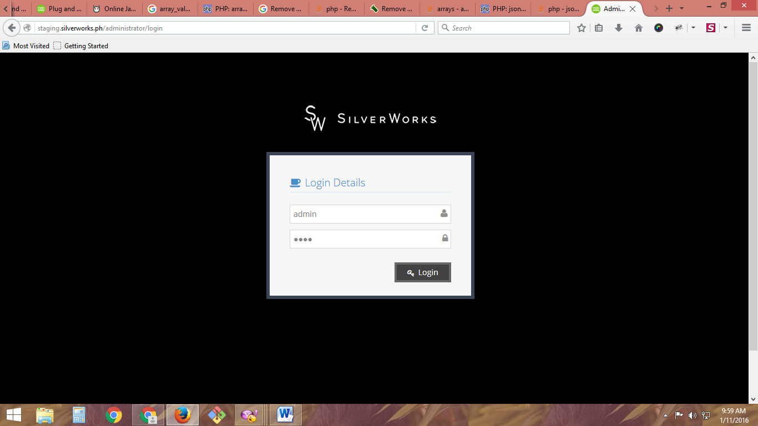

2. Click **Blog Manager**.

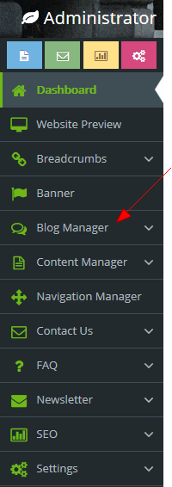

3. Click **Items**.

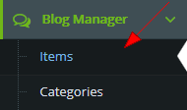

4. To update multiple items.

4.1. Put a check mark on items to be updated.



4.2. Select an action (Activate, Deactivate or Delete) to be used in selected (checked) items. And submit to perform the action.

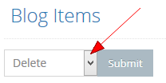

4.3. A popup modal will appear for final confirmation before the action to be performed. Click OK to proceed.

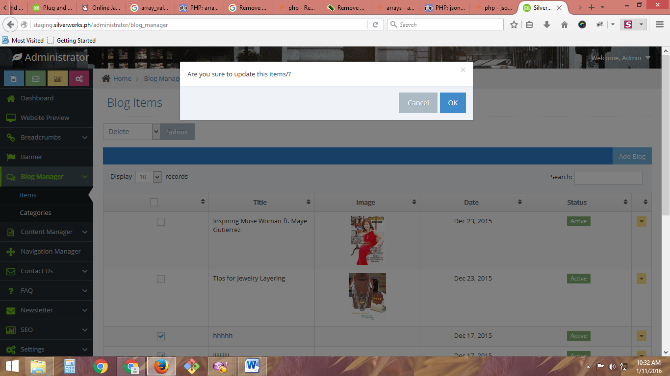

4.4. A notification message will appear.

